More Actions

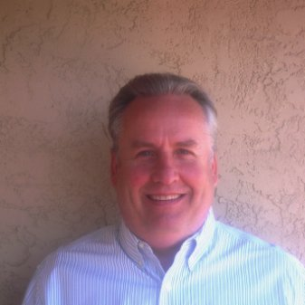

1st degree connection1st

Robert McCarthy

Factoring Professional

Transfac Capital, Inc.

 State University of New York / Orange

El Dorado Hills, California

 500+ 500+ connections

[**Message**](https://www.linkedin.com/messaging/compose/?recipient=ACoAAAFQZ90BlYGreA5HyjxNfBd7DpcmEW5G6O8)

With over 17 years in finance, I have experience in asset based lending, factoring, inventory finance, purchase order finance, SBA guaranteed loans, commercial lines of credit, equipment leasing / purchase, merchant cash advance loans and term loans. I work with businesses seeking factoring and other financial services and develop mutually beneficial referral relationships from coast to coast and I am focused on helping my clients get immediate access to working capital through factoring and other products.  
  
I am available anytime to discuss factoring and its benefits for your company or your client's company. If you are a financial consultant that provides financial solutions for your clients we will pay generous referral fees for the life of the transaction.  
  
Specialties: Asset based lending, factoring, inventory finance, purchase order finance, SBA guaranteed loans, commercial lines of credit, equipment leasing / purchase and term loans See less

Highlights

**[[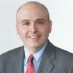](https://www.linkedin.com/in/mccarthyrobert/connections/shared/)](https://www.linkedin.com/in/mccarthyrobert/connections/shared/)**

**[25 Mutual Connections](https://www.linkedin.com/in/mccarthyrobert/connections/shared/)**

[You and Robert both know Chris Lehnes, Mary Koncir, and 23 others](https://www.linkedin.com/in/mccarthyrobert/connections/shared/)

* 

**2 Mutual Groups**

You and Robert are both in the Factoring Brokers and Funding the "Unbankable" groups

Show more Show more highlights

Experience

**[[](https://www.linkedin.com/company-beta/683906/)](https://www.linkedin.com/company-beta/683906/)**

**[Factoring Sales Manager](https://www.linkedin.com/company-beta/683906/)**

[Company NameTransfac Capital, Inc.](https://www.linkedin.com/company-beta/683906/)

[Dates EmployedMay 2010 – Present](https://www.linkedin.com/company-beta/683906/)

[Employment Duration6 yrs 11 mos](https://www.linkedin.com/company-beta/683906/)

[LocationSan Francisco Bay Area](https://www.linkedin.com/company-beta/683906/)

I work with referral sources from coast to coast and I am focused on helping my clients get immediate access to working capital through factoring and other financing products.

See lessSee less about Factoring Sales Manager, Transfac Capital, Inc.

**[Factoring Sales Manager](https://www.linkedin.com/company-beta/849390/)**

[Company NameStearns Bank](https://www.linkedin.com/company-beta/849390/)

[Dates EmployedJun 2009 – May 2010](https://www.linkedin.com/company-beta/849390/)

[Employment Duration1 yr](https://www.linkedin.com/company-beta/849390/)

**[[Bay View Funding](https://www.linkedin.com/company-beta/51067/)](https://www.linkedin.com/company-beta/51067/)**

**[Factoring Underwriter](https://www.linkedin.com/company-beta/51067/)**

[Company NameBay View Funding](https://www.linkedin.com/company-beta/51067/)

[Dates EmployedMar 2006 – Feb 2009](https://www.linkedin.com/company-beta/51067/)

[Employment Duration3 yrs](https://www.linkedin.com/company-beta/51067/)

See descriptionSee more about Factoring Underwriter, Bay View Funding

**Factoring Underwriter**

Company NameAlliance Financial Capital, Inc.

Dates EmployedFeb 1998 – Oct 2005

Employment Duration7 yrs 9 mos

LocationSan Francisco Bay Area

See descriptionSee more about Factoring Underwriter, Alliance Financial Capital, Inc.

Education

**State University of New York / Orange**

Field Of StudyBusiness Administration

Dates attended or expected graduation1977 – 1979

Featured Skills & Endorsements

**[Asset Based Lending](https://www.linkedin.com/in/mccarthyrobert/skills/(ACoAAAFQZ90BlYGreA5HyjxNfBd7DpcmEW5G6O8,4)/)**[See 79 endorsements for Asset Based Lending79](https://www.linkedin.com/in/mccarthyrobert/skills/(ACoAAAFQZ90BlYGreA5HyjxNfBd7DpcmEW5G6O8,4)/)

Endorse

* + 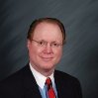

[Endorsed by **Gregory Hughes and 19 others who are highly skilled at this**](https://www.linkedin.com/in/mccarthyrobert/skills/(ACoAAAFQZ90BlYGreA5HyjxNfBd7DpcmEW5G6O8,4)/elites/)

* + 

[Endorsed by **Michelle Duran and 3 other mutual connections**](https://www.linkedin.com/in/mccarthyrobert/skills/(ACoAAAFQZ90BlYGreA5HyjxNfBd7DpcmEW5G6O8,4)/shared-connections/)

**[Factoring](https://www.linkedin.com/in/mccarthyrobert/skills/(ACoAAAFQZ90BlYGreA5HyjxNfBd7DpcmEW5G6O8,3)/)**[See 53 endorsements for Factoring53](https://www.linkedin.com/in/mccarthyrobert/skills/(ACoAAAFQZ90BlYGreA5HyjxNfBd7DpcmEW5G6O8,3)/)

Endorse

* + 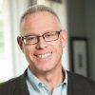

[Endorsed by **Randall Haney and 7 others who are highly skilled at this**](https://www.linkedin.com/in/mccarthyrobert/skills/(ACoAAAFQZ90BlYGreA5HyjxNfBd7DpcmEW5G6O8,3)/elites/)

* + 

[Endorsed by **Michelle Duran and 3 other mutual connections**](https://www.linkedin.com/in/mccarthyrobert/skills/(ACoAAAFQZ90BlYGreA5HyjxNfBd7DpcmEW5G6O8,3)/shared-connections/)

**[Credit](https://www.linkedin.com/in/mccarthyrobert/skills/(ACoAAAFQZ90BlYGreA5HyjxNfBd7DpcmEW5G6O8,5)/)**[See 53 endorsements for Credit53](https://www.linkedin.com/in/mccarthyrobert/skills/(ACoAAAFQZ90BlYGreA5HyjxNfBd7DpcmEW5G6O8,5)/)

Endorse

* + 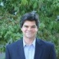

[Endorsed by **Larry Artman and 9 others who are highly skilled at this**](https://www.linkedin.com/in/mccarthyrobert/skills/(ACoAAAFQZ90BlYGreA5HyjxNfBd7DpcmEW5G6O8,5)/elites/)

* + 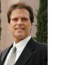

[Endorsed by **Jay Haldeman and 3 other mutual connections**](https://www.linkedin.com/in/mccarthyrobert/skills/(ACoAAAFQZ90BlYGreA5HyjxNfBd7DpcmEW5G6O8,5)/shared-connections/)

View 47 more View 47 more skills

Recommendations

* [**Received (7)**](https://www.linkedin.com/in/mccarthyrobert/connections/#ember5095)
* [**Given (6)**](https://www.linkedin.com/in/mccarthyrobert/connections/#ember5120)
* **[[](https://www.linkedin.com/in/rosalynn-gelfo-4a8a5a6/)](https://www.linkedin.com/in/rosalynn-gelfo-4a8a5a6/)**

**[Rosalynn Gelfo](https://www.linkedin.com/in/rosalynn-gelfo-4a8a5a6/)**

[Vice President, Commercial and SBA Lending](https://www.linkedin.com/in/rosalynn-gelfo-4a8a5a6/)

[December 14, 2011, Robert was senior to Rosalynn but didn’t manage directly](https://www.linkedin.com/in/rosalynn-gelfo-4a8a5a6/)

I have worked with Bob at Alliance Financial Capital for a couple of years. Bob was the Senior Underwriter and was responsible for reviewing deals that l submitted for approval. Bob was very responsive and reliable in getting back to me with answers in a timely manner. Bob is pleasant to work with as he is very personable..a joy to work with! Bob gets the job done!

* **[[](https://www.linkedin.com/in/steve-guth-a49981/)](https://www.linkedin.com/in/steve-guth-a49981/)**

**[Steve Guth](https://www.linkedin.com/in/steve-guth-a49981/)**

[Commerical Banker - Auto Dealer Services at JPMorgan Chase](https://www.linkedin.com/in/steve-guth-a49981/)

[December 8, 2011, Steve worked with Robert but at different companies](https://www.linkedin.com/in/steve-guth-a49981/)

Bob has been a great partner for me to work with at both his current role and previous factor jobs he has worked. He has shown to be more than just a 'salesman' as a value added advisor to companies that I have referred to him for services. He is always totally honest if factoring might not be the best solution, and does what is best for the company. Anyone looking to hire Bob or send referrals to him can be assured he will take care of the client.

**View 5 more recommendations**

**View 5 more recommendations recommendations**

Following

**[[](https://www.linkedin.com/pulse/feed/channel/6036913024072171520)](https://www.linkedin.com/pulse/feed/channel/6036913024072171520" \t "_blank)**

**[Pulse](https://www.linkedin.com/pulse/feed/channel/6036913024072171520" \t "_blank)**

[1,487,838 followers](https://www.linkedin.com/pulse/feed/channel/6036913024072171520" \t "_blank)

**[[FactorNet  Lead Referral and Networking Group](https://www.linkedin.com/groups/73880)](https://www.linkedin.com/groups/73880" \t "_blank)**

**[FactorNet Lead Referral and Networking Group](https://www.linkedin.com/groups/73880" \t "_blank)**

[9,621 members](https://www.linkedin.com/groups/73880" \t "_blank)

**[[Factoring Brokers](https://www.linkedin.com/groups/1788084)](https://www.linkedin.com/groups/1788084" \t "_blank)**

**[Factoring Brokers](https://www.linkedin.com/groups/1788084" \t "_blank)**

[5,553 members](https://www.linkedin.com/groups/1788084" \t "_blank)

**[[](https://www.linkedin.com/company-beta/683906/)](https://www.linkedin.com/company-beta/683906/)**

**[Transfac Capital Inc](https://www.linkedin.com/company-beta/683906/)**

[260 followers](https://www.linkedin.com/company-beta/683906/)

**[[Funding the "Unbankable"](https://www.linkedin.com/groups/4826753)](https://www.linkedin.com/groups/4826753" \t "_blank)**

**[Funding the "Unbankable"](https://www.linkedin.com/groups/4826753" \t "_blank)**

[965 members](https://www.linkedin.com/groups/4826753" \t "_blank)

**[[SUMMIT Financial Resources: Working Capital Financing](https://www.linkedin.com/company-beta/618462/)](https://www.linkedin.com/company-beta/618462/)**

**[SUMMIT Financial Resources: Working Capital Financing](https://www.linkedin.com/company-beta/618462/)**

[422 followers](https://www.linkedin.com/company-beta/618462/)

**[See connections (500+)](https://www.linkedin.com/in/mccarthyrobert/connections/)**

**[[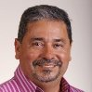](https://www.linkedin.com/in/mccarthyrobert/connections/)](https://www.linkedin.com/in/mccarthyrobert/connections/)**

**[[](https://www.linkedin.com/in/mccarthyrobert/connections/)](https://www.linkedin.com/in/mccarthyrobert/connections/)**

**[[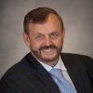](https://www.linkedin.com/in/mccarthyrobert/connections/)](https://www.linkedin.com/in/mccarthyrobert/connections/)**

**Contact and Personal Info**

**Robert’s Profile, Websites, Phones, Address, and Email**

Show more See more contact and personal info

People Also Viewed

* [[](https://www.linkedin.com/in/michelle-myers-9ba5ba12/)](https://www.linkedin.com/in/michelle-myers-9ba5ba12/)

**[Michelle Myers](https://www.linkedin.com/in/michelle-myers-9ba5ba12/)**[2nd degree connection2nd](https://www.linkedin.com/in/michelle-myers-9ba5ba12/)

[Business Development Manager at Third Coast Commercial Capital, Inc](https://www.linkedin.com/in/michelle-myers-9ba5ba12/)

* [[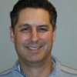](https://www.linkedin.com/in/thomassmeltz/)](https://www.linkedin.com/in/thomassmeltz/)

**[Thomas Smeltz](https://www.linkedin.com/in/thomassmeltz/)**[2nd degree connection2nd](https://www.linkedin.com/in/thomassmeltz/)

[Factoring Professional](https://www.linkedin.com/in/thomassmeltz/)

* [[](https://www.linkedin.com/in/tanyafontenot/)](https://www.linkedin.com/in/tanyafontenot/)

**[Tanya Fontenot](https://www.linkedin.com/in/tanyafontenot/)**[1st degree connection1st](https://www.linkedin.com/in/tanyafontenot/)

[Vice President at Transfac Capital. (225) 337-3170](https://www.linkedin.com/in/tanyafontenot/)

* [[](https://www.linkedin.com/in/racheloblad/)](https://www.linkedin.com/in/racheloblad/)

**[Rachel Beall](https://www.linkedin.com/in/racheloblad/)**[You](https://www.linkedin.com/in/racheloblad/)

[Marketing and Sales Coordinator at Transfac Capital Inc](https://www.linkedin.com/in/racheloblad/)

* [[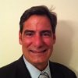](https://www.linkedin.com/in/ignacio-hernandez-0094b325/)](https://www.linkedin.com/in/ignacio-hernandez-0094b325/)

**[Ignacio Hernandez](https://www.linkedin.com/in/ignacio-hernandez-0094b325/)**[2nd degree connection2nd](https://www.linkedin.com/in/ignacio-hernandez-0094b325/)

[Senior Vice President and Factoring Sales Manager at Ocean Bank](https://www.linkedin.com/in/ignacio-hernandez-0094b325/)

* [[](https://www.linkedin.com/in/ashley-polek-8630401b/)](https://www.linkedin.com/in/ashley-polek-8630401b/)

**[Ashley Polek](https://www.linkedin.com/in/ashley-polek-8630401b/)**[2nd degree connection2nd](https://www.linkedin.com/in/ashley-polek-8630401b/)

[Factoring Consultant/eCapital](https://www.linkedin.com/in/ashley-polek-8630401b/)

* [[](https://www.linkedin.com/in/michelle-duran-51397b7/)](https://www.linkedin.com/in/michelle-duran-51397b7/)

**[Michelle Duran](https://www.linkedin.com/in/michelle-duran-51397b7/)**[1st degree connection1st](https://www.linkedin.com/in/michelle-duran-51397b7/)

[Vice President of Inside Sales/ Business Development Managaer at Transfac Capital Inc](https://www.linkedin.com/in/michelle-duran-51397b7/)

* [[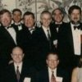](https://www.linkedin.com/in/lou-horowitz-a5203045/)](https://www.linkedin.com/in/lou-horowitz-a5203045/)

**[Lou Horowitz](https://www.linkedin.com/in/lou-horowitz-a5203045/)**[2nd degree connection2nd](https://www.linkedin.com/in/lou-horowitz-a5203045/)

[Director, Factoring and Contract Finance at Wells Fargo](https://www.linkedin.com/in/lou-horowitz-a5203045/)

* [[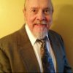](https://www.linkedin.com/in/allan-quackenbush-23967055/)](https://www.linkedin.com/in/allan-quackenbush-23967055/)

**[Allan Quackenbush](https://www.linkedin.com/in/allan-quackenbush-23967055/)**[2nd degree connection2nd](https://www.linkedin.com/in/allan-quackenbush-23967055/)

[Non-Traditional Business Loans | Factoring Accounts Receivables | Equipment Lease to Own | Lines of Credit | Financing](https://www.linkedin.com/in/allan-quackenbush-23967055/)

* [[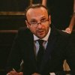](https://www.linkedin.com/in/dragan-trajkovski-485a51116/)](https://www.linkedin.com/in/dragan-trajkovski-485a51116/)

**[Dragan Trajkovski](https://www.linkedin.com/in/dragan-trajkovski-485a51116/)**[3rd degree connection3rd](https://www.linkedin.com/in/dragan-trajkovski-485a51116/)

[Factoring Consultant. Factoring and A/R financing for businesses located in the US. Turn invoices into cash today!](https://www.linkedin.com/in/dragan-trajkovski-485a51116/)

LinkedIn Footer Content

LinkedIn

* [**About**](https://www.linkedin.com/about-us)

* [**Talent Solutions**](https://business.linkedin.com/talent-solutions?trk=d_flagship3_nav&src=li-footer)

* [**Community Guidelines**](https://linkedin.com/help/linkedin/answer/34593)
* [**Careers**](https://www.linkedin.com/company/linkedin/careers?trk=d_flagship3_nav)

* [**Marketing Solutions**](https://business.linkedin.com/marketing-solutions?trk=hb_ft_ads&src=li-footer)

* Privacy & Terms
* [**Advertising**](https://www.linkedin.com/ad/start?trk=nav_responsive_sub_nav_advertise)

* [**Sales Solutions**](https://business.linkedin.com/sales-solutions?trk=d_flagship3_nav&src=li-footer)

* Send feedback
* [**Mobile**](https://mobile.linkedin.com/)

* [**Small Business**](https://smallbusiness.linkedin.com/?&src=li-footer)

LinkedIn Corporation © 2017

* [**Questions?**](https://www.linkedin.com/help/linkedin?trk=neptune_help)

Visit our Help Center.

* [**Manage your account and privacy.**](https://www.linkedin.com/psettings/)

Go to your Settings.

Select Language



Robert’s Connections

Close Modal

* [Shared](https://www.linkedin.com/in/mccarthyrobert/connections/shared/)
* [All](https://www.linkedin.com/in/mccarthyrobert/connections/)
* **[[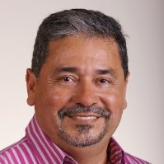](https://www.linkedin.com/in/jamesduran/)](https://www.linkedin.com/in/jamesduran/)**

**[Member Name](https://www.linkedin.com/in/jamesduran/)**

**[James Duran](https://www.linkedin.com/in/jamesduran/)**[2nd degree connection2nd](https://www.linkedin.com/in/jamesduran/)

**[Member Occupation](https://www.linkedin.com/in/jamesduran/)**

[Board Member and Chair at CHCC Foundation](https://www.linkedin.com/in/jamesduran/)

* **[[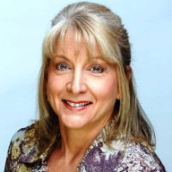](https://www.linkedin.com/in/diane-homa-86916/)](https://www.linkedin.com/in/diane-homa-86916/)**

**[Member Name](https://www.linkedin.com/in/diane-homa-86916/)**

**[Diane Homa](https://www.linkedin.com/in/diane-homa-86916/)**[2nd degree connection2nd](https://www.linkedin.com/in/diane-homa-86916/)

**[Member Occupation](https://www.linkedin.com/in/diane-homa-86916/)**

[Board Director, Humane Society Tampa Bay](https://www.linkedin.com/in/diane-homa-86916/)

* **[[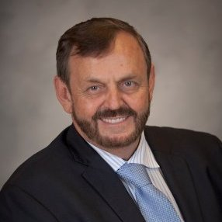](https://www.linkedin.com/in/davidrains/)](https://www.linkedin.com/in/davidrains/)**

**[Member Name](https://www.linkedin.com/in/davidrains/)**

**[David Rains](https://www.linkedin.com/in/davidrains/)**[2nd degree connection2nd](https://www.linkedin.com/in/davidrains/)

**[Member Occupation](https://www.linkedin.com/in/davidrains/)**

[CEO / President / Consultant specializing in Asset Based Lending, Factoring, Trade Finance, Start-Ups and Recruiting](https://www.linkedin.com/in/davidrains/)

* **[[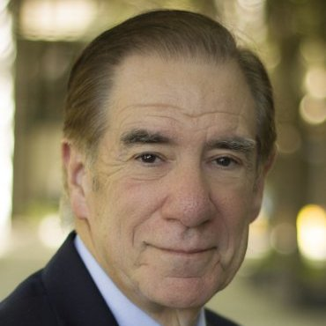](https://www.linkedin.com/in/mike-harris-3b826/)](https://www.linkedin.com/in/mike-harris-3b826/)**

**[Member Name](https://www.linkedin.com/in/mike-harris-3b826/)**

**[Mike Harris](https://www.linkedin.com/in/mike-harris-3b826/)**[2nd degree connection2nd](https://www.linkedin.com/in/mike-harris-3b826/)

**[Member Occupation](https://www.linkedin.com/in/mike-harris-3b826/)**

[Owner, Astra Funding Group](https://www.linkedin.com/in/mike-harris-3b826/)

* **[[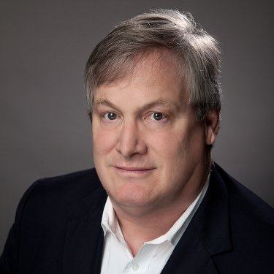](https://www.linkedin.com/in/paul-duren/)](https://www.linkedin.com/in/paul-duren/)**

**[Member Name](https://www.linkedin.com/in/paul-duren/)**

**[Paul Duren](https://www.linkedin.com/in/paul-duren/)**[2nd degree connection2nd](https://www.linkedin.com/in/paul-duren/)

**[Member Occupation](https://www.linkedin.com/in/paul-duren/)**

[Senior Vice President at Bridge Bank](https://www.linkedin.com/in/paul-duren/)

* **[[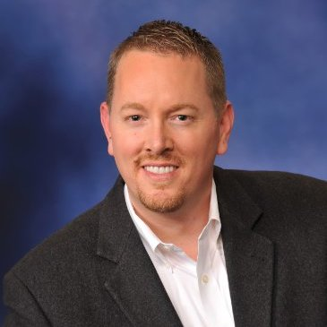](https://www.linkedin.com/in/guysimpson1/)](https://www.linkedin.com/in/guysimpson1/)**

**[Member Name](https://www.linkedin.com/in/guysimpson1/)**

**[Guy Simpson](https://www.linkedin.com/in/guysimpson1/)**[2nd degree connection2nd](https://www.linkedin.com/in/guysimpson1/)

**[Member Occupation](https://www.linkedin.com/in/guysimpson1/)**

[Former Managing Director in Comerica Bank's Equity Fund Services Group](https://www.linkedin.com/in/guysimpson1/)

* **[[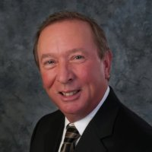](https://www.linkedin.com/in/joe-palermo-9a63a/)](https://www.linkedin.com/in/joe-palermo-9a63a/)**

**[Member Name](https://www.linkedin.com/in/joe-palermo-9a63a/)**

**[Joe Palermo](https://www.linkedin.com/in/joe-palermo-9a63a/)**[2nd degree connection2nd](https://www.linkedin.com/in/joe-palermo-9a63a/)

**[Member Occupation](https://www.linkedin.com/in/joe-palermo-9a63a/)**

[Senior Advisor at Clairfield Partners](https://www.linkedin.com/in/joe-palermo-9a63a/)

* **[[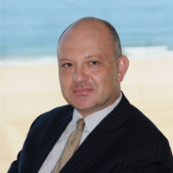](https://www.linkedin.com/in/alexkasdan/)](https://www.linkedin.com/in/alexkasdan/)**

**[Member Name](https://www.linkedin.com/in/alexkasdan/)**

**[Alex Kasdan](https://www.linkedin.com/in/alexkasdan/)**[2nd degree connection2nd](https://www.linkedin.com/in/alexkasdan/)

**[Member Occupation](https://www.linkedin.com/in/alexkasdan/)**

[Investment Banker, Senior Managing Director, DelMorgan & Co.](https://www.linkedin.com/in/alexkasdan/)

* **[[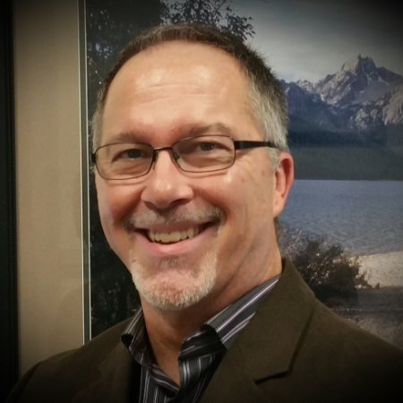](https://www.linkedin.com/in/diversifiedfundingservices/)](https://www.linkedin.com/in/diversifiedfundingservices/)**

**[Member Name](https://www.linkedin.com/in/diversifiedfundingservices/)**

**[Mark Little](https://www.linkedin.com/in/diversifiedfundingservices/)**[2nd degree connection2nd](https://www.linkedin.com/in/diversifiedfundingservices/)

**[Member Occupation](https://www.linkedin.com/in/diversifiedfundingservices/)**

[President / CEO at Diversified Funding Services, Inc](https://www.linkedin.com/in/diversifiedfundingservices/)

* **[[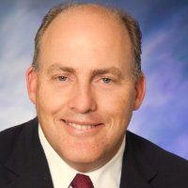](https://www.linkedin.com/in/paul-schuldiner-44787/)](https://www.linkedin.com/in/paul-schuldiner-44787/)**

**[Member Name](https://www.linkedin.com/in/paul-schuldiner-44787/)**

**[Paul Schuldiner](https://www.linkedin.com/in/paul-schuldiner-44787/)**[2nd degree connection2nd](https://www.linkedin.com/in/paul-schuldiner-44787/)

**[Member Occupation](https://www.linkedin.com/in/paul-schuldiner-44787/)**

[Senior Vice President - Division Head of Rosenthal Trade Capital at Rosenthal & Rosenthal, Inc.](https://www.linkedin.com/in/paul-schuldiner-44787/)

* **[[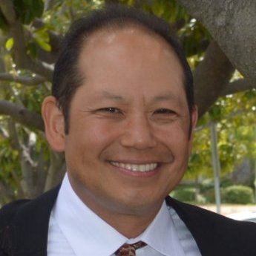](https://www.linkedin.com/in/garycchang/)](https://www.linkedin.com/in/garycchang/)**

**[Member Name](https://www.linkedin.com/in/garycchang/)**

**[Gary Chang](https://www.linkedin.com/in/garycchang/)**[2nd degree connection2nd](https://www.linkedin.com/in/garycchang/)

**[Member Occupation](https://www.linkedin.com/in/garycchang/)**

[Director of Business Development and Strategic Partnerships at Commonwealth Foreign Exchange](https://www.linkedin.com/in/garycchang/)

**[Member Name](https://www.linkedin.com/in/rajeevseshadri/)**

**[Rajeev (Raj) Seshadri](https://www.linkedin.com/in/rajeevseshadri/)**[2nd degree connection2nd](https://www.linkedin.com/in/rajeevseshadri/)

**[Member Occupation](https://www.linkedin.com/in/rajeevseshadri/)**

[VP Finance & CFO at Optronic Technologies, Inc](https://www.linkedin.com/in/rajeevseshadri/)

**[Member Name](https://www.linkedin.com/in/tosh-p-336116/)**

**[Tosh P.](https://www.linkedin.com/in/tosh-p-336116/)**[2nd degree connection2nd](https://www.linkedin.com/in/tosh-p-336116/)

**[Member Occupation](https://www.linkedin.com/in/tosh-p-336116/)**

[Principal at MH Capital](https://www.linkedin.com/in/tosh-p-336116/)

**[Member Name](https://www.linkedin.com/in/johnfedewa/)**

**[John Fedewa](https://www.linkedin.com/in/johnfedewa/)**[2nd degree connection2nd](https://www.linkedin.com/in/johnfedewa/)

**[Member Occupation](https://www.linkedin.com/in/johnfedewa/)**

[President, armcor.com LLC](https://www.linkedin.com/in/johnfedewa/)

* **[[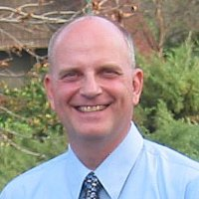](https://www.linkedin.com/in/davekocharhook/)](https://www.linkedin.com/in/davekocharhook/)**

**[Member Name](https://www.linkedin.com/in/davekocharhook/)**

**[Dave Kocharhook](https://www.linkedin.com/in/davekocharhook/)**[2nd degree connection2nd](https://www.linkedin.com/in/davekocharhook/)

**[Member Occupation](https://www.linkedin.com/in/davekocharhook/)**

[Vice President Sales at 1st PMF Bancorp](https://www.linkedin.com/in/davekocharhook/)

* **[[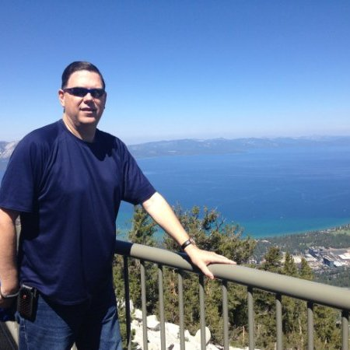](https://www.linkedin.com/in/dan-popovich-103140/)](https://www.linkedin.com/in/dan-popovich-103140/)**

**[Member Name](https://www.linkedin.com/in/dan-popovich-103140/)**

**[Dan Popovich](https://www.linkedin.com/in/dan-popovich-103140/)**[2nd degree connection2nd](https://www.linkedin.com/in/dan-popovich-103140/)

**[Member Occupation](https://www.linkedin.com/in/dan-popovich-103140/)**

[President & Managing Member](https://www.linkedin.com/in/dan-popovich-103140/)

* **[[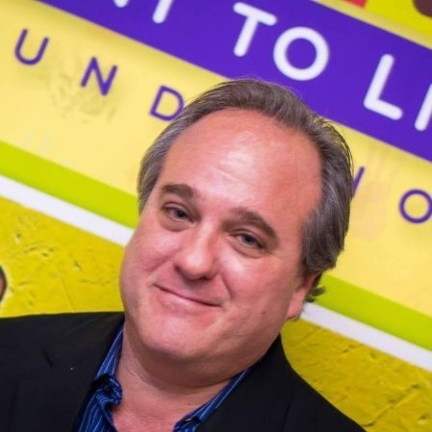](https://www.linkedin.com/in/metrocapital/)](https://www.linkedin.com/in/metrocapital/)**

**[Member Name](https://www.linkedin.com/in/metrocapital/)**

**[Robert Schwartz](https://www.linkedin.com/in/metrocapital/)**[2nd degree connection2nd](https://www.linkedin.com/in/metrocapital/)

**[Member Occupation](https://www.linkedin.com/in/metrocapital/)**

[President - Metro Capital](https://www.linkedin.com/in/metrocapital/)

* **[[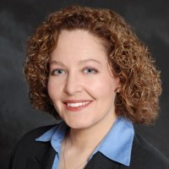](https://www.linkedin.com/in/phyllis-brown-479149/)](https://www.linkedin.com/in/phyllis-brown-479149/)**

**[Member Name](https://www.linkedin.com/in/phyllis-brown-479149/)**

**[Phyllis Brown](https://www.linkedin.com/in/phyllis-brown-479149/)**[2nd degree connection2nd](https://www.linkedin.com/in/phyllis-brown-479149/)

**[Member Occupation](https://www.linkedin.com/in/phyllis-brown-479149/)**

[SVP, Marketing & Sales at My Cloud Grocer](https://www.linkedin.com/in/phyllis-brown-479149/)

* **[[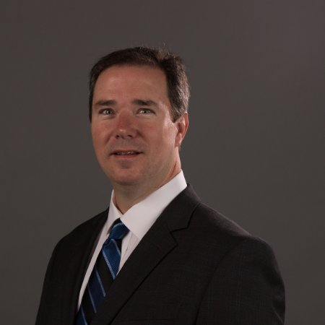](https://www.linkedin.com/in/dalebusbee/)](https://www.linkedin.com/in/dalebusbee/)**

**[Member Name](https://www.linkedin.com/in/dalebusbee/)**

**[Dale Busbee, CSP, TSC](https://www.linkedin.com/in/dalebusbee/)**[2nd degree connection2nd](https://www.linkedin.com/in/dalebusbee/)

**[Member Occupation](https://www.linkedin.com/in/dalebusbee/)**

[Working Capital Solutions for Small Businesses | dale@prosperityfunding.com](https://www.linkedin.com/in/dalebusbee/)

* **[[](https://www.linkedin.com/in/rich-pirovano-a83156/)](https://www.linkedin.com/in/rich-pirovano-a83156/)**

**[Member Name](https://www.linkedin.com/in/rich-pirovano-a83156/)**

**[Rich Pirovano](https://www.linkedin.com/in/rich-pirovano-a83156/)**[2nd degree connection2nd](https://www.linkedin.com/in/rich-pirovano-a83156/)

**[Member Occupation](https://www.linkedin.com/in/rich-pirovano-a83156/)**

[President of KPCP Merchant Capital & Manager at Matrix Payment Systems](https://www.linkedin.com/in/rich-pirovano-a83156/)

* **[[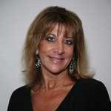](https://www.linkedin.com/in/carrie-jenkins-71b177/)](https://www.linkedin.com/in/carrie-jenkins-71b177/)**

**[Member Name](https://www.linkedin.com/in/carrie-jenkins-71b177/)**

**[Carrie Jenkins](https://www.linkedin.com/in/carrie-jenkins-71b177/)**[2nd degree connection2nd](https://www.linkedin.com/in/carrie-jenkins-71b177/)

**[Member Occupation](https://www.linkedin.com/in/carrie-jenkins-71b177/)**

[Vice President, Business Development Officer at Crestmark Bank](https://www.linkedin.com/in/carrie-jenkins-71b177/)

* **[[](https://www.linkedin.com/in/annegordon1/)](https://www.linkedin.com/in/annegordon1/)**

**[Member Name](https://www.linkedin.com/in/annegordon1/)**

**[Anne Gordon](https://www.linkedin.com/in/annegordon1/)**[2nd degree connection2nd](https://www.linkedin.com/in/annegordon1/)

**[Member Occupation](https://www.linkedin.com/in/annegordon1/)**

[Working Capital for Companies in Start-up, Growth, or Survival Mode. When Your Bank says NO We can Make It GO!](https://www.linkedin.com/in/annegordon1/)

* **[[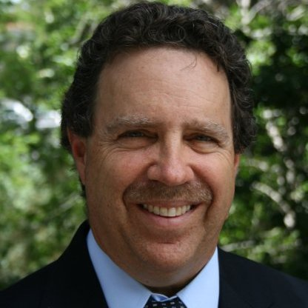](https://www.linkedin.com/in/andrew-krone-0291bb/)](https://www.linkedin.com/in/andrew-krone-0291bb/)**

**[Member Name](https://www.linkedin.com/in/andrew-krone-0291bb/)**

**[Andrew Krone](https://www.linkedin.com/in/andrew-krone-0291bb/)**[2nd degree connection2nd](https://www.linkedin.com/in/andrew-krone-0291bb/)

**[Member Occupation](https://www.linkedin.com/in/andrew-krone-0291bb/)**

[SR. V.P. Sales at Marble Bridge Funding Group](https://www.linkedin.com/in/andrew-krone-0291bb/)

* **[[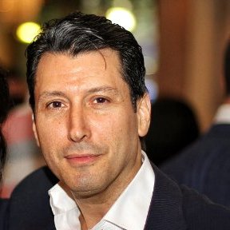](https://www.linkedin.com/in/azadian/)](https://www.linkedin.com/in/azadian/)**

**[Member Name](https://www.linkedin.com/in/azadian/)**

**[Raffi Azadian](https://www.linkedin.com/in/azadian/)**[2nd degree connection2nd](https://www.linkedin.com/in/azadian/)

**[Member Occupation](https://www.linkedin.com/in/azadian/)**

[CEO of Azadian Group](https://www.linkedin.com/in/azadian/)

* **[[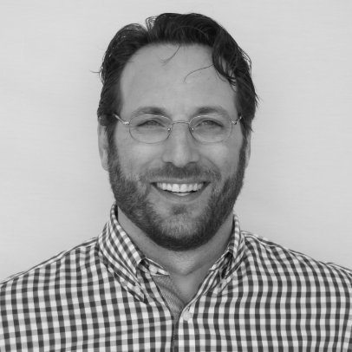](https://www.linkedin.com/in/mikebernstein1/)](https://www.linkedin.com/in/mikebernstein1/)**

**[Member Name](https://www.linkedin.com/in/mikebernstein1/)**

**[Michael Bernstein](https://www.linkedin.com/in/mikebernstein1/)**[2nd degree connection2nd](https://www.linkedin.com/in/mikebernstein1/)

**[Member Occupation](https://www.linkedin.com/in/mikebernstein1/)**

[Vice President at Wasserman Media Group](https://www.linkedin.com/in/mikebernstein1/)

* **[[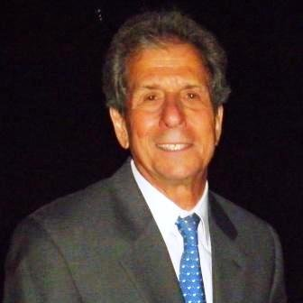](https://www.linkedin.com/in/robert-collier-45b235/)](https://www.linkedin.com/in/robert-collier-45b235/)**

**[Member Name](https://www.linkedin.com/in/robert-collier-45b235/)**

**[Robert Collier](https://www.linkedin.com/in/robert-collier-45b235/)**[2nd degree connection2nd](https://www.linkedin.com/in/robert-collier-45b235/)

**[Member Occupation](https://www.linkedin.com/in/robert-collier-45b235/)**

[Managing Partner: Purchase Order, Production & Inventory Finance](https://www.linkedin.com/in/robert-collier-45b235/)

* **[[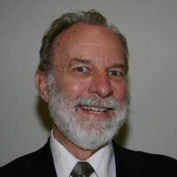](https://www.linkedin.com/in/allen-clason-1a1260/)](https://www.linkedin.com/in/allen-clason-1a1260/)**

**[Member Name](https://www.linkedin.com/in/allen-clason-1a1260/)**

**[Allen Clason](https://www.linkedin.com/in/allen-clason-1a1260/)**[2nd degree connection2nd](https://www.linkedin.com/in/allen-clason-1a1260/)

**[Member Occupation](https://www.linkedin.com/in/allen-clason-1a1260/)**

[President at Quest Financial Services](https://www.linkedin.com/in/allen-clason-1a1260/)

* **[[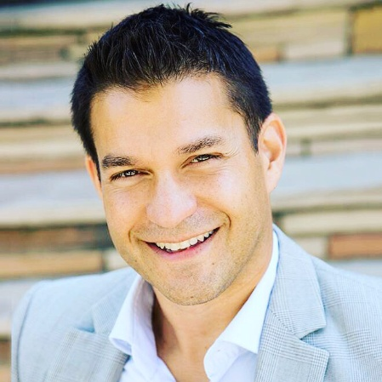](https://www.linkedin.com/in/shane-passarelli-b31296/)](https://www.linkedin.com/in/shane-passarelli-b31296/)**

**[Member Name](https://www.linkedin.com/in/shane-passarelli-b31296/)**

**[Shane Passarelli](https://www.linkedin.com/in/shane-passarelli-b31296/)**[2nd degree connection2nd](https://www.linkedin.com/in/shane-passarelli-b31296/)

**[Member Occupation](https://www.linkedin.com/in/shane-passarelli-b31296/)**

[Senior Vice President at Capital One](https://www.linkedin.com/in/shane-passarelli-b31296/)

* **[[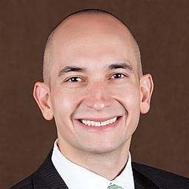](https://www.linkedin.com/in/rodrigoriadi/)](https://www.linkedin.com/in/rodrigoriadi/)**

**[Member Name](https://www.linkedin.com/in/rodrigoriadi/)**

**[Rodrigo Riadi](https://www.linkedin.com/in/rodrigoriadi/)**[2nd degree connection2nd](https://www.linkedin.com/in/rodrigoriadi/)

**[Member Occupation](https://www.linkedin.com/in/rodrigoriadi/)**

[Managing Principal at Front Range Factoring](https://www.linkedin.com/in/rodrigoriadi/)

* **[[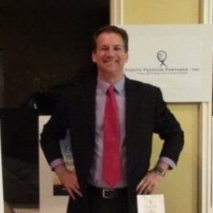](https://www.linkedin.com/in/mitchellholland/)](https://www.linkedin.com/in/mitchellholland/)**

**[Member Name](https://www.linkedin.com/in/mitchellholland/)**

**[Mitchell Holland](https://www.linkedin.com/in/mitchellholland/)**[2nd degree connection2nd](https://www.linkedin.com/in/mitchellholland/)

**[Member Occupation](https://www.linkedin.com/in/mitchellholland/)**

[Director of Special Events](https://www.linkedin.com/in/mitchellholland/)

* **[[](https://www.linkedin.com/in/drindsberg/)](https://www.linkedin.com/in/drindsberg/)**

**[Member Name](https://www.linkedin.com/in/drindsberg/)**

**[Daniel Rindsberg, Esq.](https://www.linkedin.com/in/drindsberg/)**[2nd degree connection2nd](https://www.linkedin.com/in/drindsberg/)

**[Member Occupation](https://www.linkedin.com/in/drindsberg/)**

[Attorney turned Entrepreneur/Investor/Merchant Banker/Corporate Strategy Consultant](https://www.linkedin.com/in/drindsberg/)

* **[[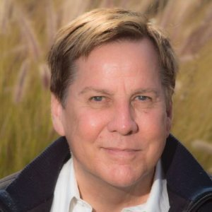](https://www.linkedin.com/in/marshall-childs-business-architecture-4a2361/)](https://www.linkedin.com/in/marshall-childs-business-architecture-4a2361/)**

**[Member Name](https://www.linkedin.com/in/marshall-childs-business-architecture-4a2361/)**

**[Marshall Childs - Business Architecture](https://www.linkedin.com/in/marshall-childs-business-architecture-4a2361/)**[2nd degree connection2nd](https://www.linkedin.com/in/marshall-childs-business-architecture-4a2361/)

**[Member Occupation](https://www.linkedin.com/in/marshall-childs-business-architecture-4a2361/)**

[Planning, Strategy Operations Model Analysis BusinessProcess, Software Architecture, Management](https://www.linkedin.com/in/marshall-childs-business-architecture-4a2361/)

* **[[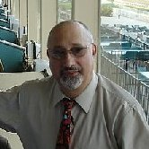](https://www.linkedin.com/in/barryshulman/)](https://www.linkedin.com/in/barryshulman/)**

**[Member Name](https://www.linkedin.com/in/barryshulman/)**

**[Barry Shulman](https://www.linkedin.com/in/barryshulman/)**[2nd degree connection2nd](https://www.linkedin.com/in/barryshulman/)

**[Member Occupation](https://www.linkedin.com/in/barryshulman/)**

[Certified Senior Account Manager PrincetonOne](https://www.linkedin.com/in/barryshulman/)

**[Member Name](https://www.linkedin.com/in/michael-durney-984432/)**

**[Michael Durney](https://www.linkedin.com/in/michael-durney-984432/)**[2nd degree connection2nd](https://www.linkedin.com/in/michael-durney-984432/)

**[Member Occupation](https://www.linkedin.com/in/michael-durney-984432/)**

[Independent Venture Capital & Private Equity Professional](https://www.linkedin.com/in/michael-durney-984432/)

* **[[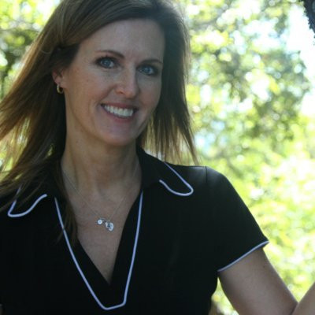](https://www.linkedin.com/in/christine-barney-736454/)](https://www.linkedin.com/in/christine-barney-736454/)**

**[Member Name](https://www.linkedin.com/in/christine-barney-736454/)**

**[Christine Barney](https://www.linkedin.com/in/christine-barney-736454/)**[2nd degree connection2nd](https://www.linkedin.com/in/christine-barney-736454/)

**[Member Occupation](https://www.linkedin.com/in/christine-barney-736454/)**

[management](https://www.linkedin.com/in/christine-barney-736454/)

* **[[](https://www.linkedin.com/in/markkeehnle/)](https://www.linkedin.com/in/markkeehnle/)**

**[Member Name](https://www.linkedin.com/in/markkeehnle/)**

**[Mark Keehnle](https://www.linkedin.com/in/markkeehnle/)**[2nd degree connection2nd](https://www.linkedin.com/in/markkeehnle/)

**[Member Occupation](https://www.linkedin.com/in/markkeehnle/)**

[Business Development Manager at Durham Commercial Capital](https://www.linkedin.com/in/markkeehnle/)

* **[[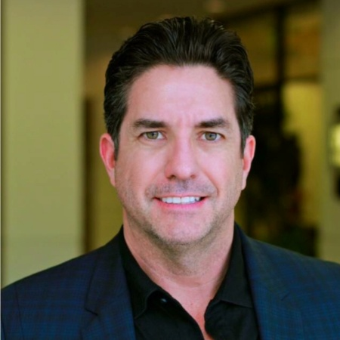](https://www.linkedin.com/in/samstamper/)](https://www.linkedin.com/in/samstamper/)**

**[Member Name](https://www.linkedin.com/in/samstamper/)**

**[🔹Sam Stamper 🔹](https://www.linkedin.com/in/samstamper/)**[2nd degree connection2nd](https://www.linkedin.com/in/samstamper/)

**[Member Occupation](https://www.linkedin.com/in/samstamper/)**

[Mortgage Banker - 949-734-4420 - American Financial Network](https://www.linkedin.com/in/samstamper/)

* **[[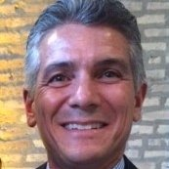](https://www.linkedin.com/in/terracinaj/)](https://www.linkedin.com/in/terracinaj/)**

**[Member Name](https://www.linkedin.com/in/terracinaj/)**

**[Joe Terracina](https://www.linkedin.com/in/terracinaj/)**[2nd degree connection2nd](https://www.linkedin.com/in/terracinaj/)

**[Member Occupation](https://www.linkedin.com/in/terracinaj/)**

[Principal Consultant at JAT Consulting](https://www.linkedin.com/in/terracinaj/)

* **[[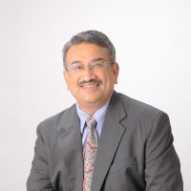](https://www.linkedin.com/in/amulpurohit/)](https://www.linkedin.com/in/amulpurohit/)**

**[Member Name](https://www.linkedin.com/in/amulpurohit/)**

**[Amul Purohit](https://www.linkedin.com/in/amulpurohit/)**[2nd degree connection2nd](https://www.linkedin.com/in/amulpurohit/)

**[Member Occupation](https://www.linkedin.com/in/amulpurohit/)**

[President/CEO, Liquid Capital of Northern California](https://www.linkedin.com/in/amulpurohit/)

**[Member Name](https://www.linkedin.com/in/elizabeth-hastings-04b674/)**

**[Elizabeth Hastings](https://www.linkedin.com/in/elizabeth-hastings-04b674/)**[2nd degree connection2nd](https://www.linkedin.com/in/elizabeth-hastings-04b674/)

**[Member Occupation](https://www.linkedin.com/in/elizabeth-hastings-04b674/)**

[Owner, Hastings Financial, Insurance and Investment Planner/Consultant](https://www.linkedin.com/in/elizabeth-hastings-04b674/)

**[Member Name](https://www.linkedin.com/in/ron-yair-a4a6a8/)**

**[Ron Yair](https://www.linkedin.com/in/ron-yair-a4a6a8/)**[2nd degree connection2nd](https://www.linkedin.com/in/ron-yair-a4a6a8/)

**[Member Occupation](https://www.linkedin.com/in/ron-yair-a4a6a8/)**

[Asset Backed Lender -Structured Credit](https://www.linkedin.com/in/ron-yair-a4a6a8/)

* **[[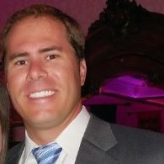](https://www.linkedin.com/in/scott-mehringer-98b704/)](https://www.linkedin.com/in/scott-mehringer-98b704/)**

**[Member Name](https://www.linkedin.com/in/scott-mehringer-98b704/)**

**[Scott Mehringer](https://www.linkedin.com/in/scott-mehringer-98b704/)**[2nd degree connection2nd](https://www.linkedin.com/in/scott-mehringer-98b704/)

**[Member Occupation](https://www.linkedin.com/in/scott-mehringer-98b704/)**

[Vice President, Northwest Region - AeroFund Financial Inc.](https://www.linkedin.com/in/scott-mehringer-98b704/)

**[Member Name](https://www.linkedin.com/in/lew-cimino-126726/)**

**[Lew Cimino](https://www.linkedin.com/in/lew-cimino-126726/)**[2nd degree connection2nd](https://www.linkedin.com/in/lew-cimino-126726/)

**[Member Occupation](https://www.linkedin.com/in/lew-cimino-126726/)**

[President, CIMINO & ASSOCIATES](https://www.linkedin.com/in/lew-cimino-126726/)

* **[[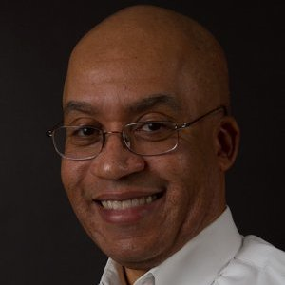](https://www.linkedin.com/in/jimshelton1/)](https://www.linkedin.com/in/jimshelton1/)**

**[Member Name](https://www.linkedin.com/in/jimshelton1/)**

**[Jim Shelton](https://www.linkedin.com/in/jimshelton1/)**[2nd degree connection2nd](https://www.linkedin.com/in/jimshelton1/)

**[Member Occupation](https://www.linkedin.com/in/jimshelton1/)**

[CEO at Shenandoah Capital](https://www.linkedin.com/in/jimshelton1/)

* **[[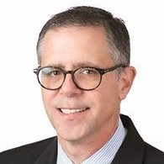](https://www.linkedin.com/in/tgiustinianocpa/)](https://www.linkedin.com/in/tgiustinianocpa/)**

**[Member Name](https://www.linkedin.com/in/tgiustinianocpa/)**

**[Todd Giustiniano, MS, CPA/ABV](https://www.linkedin.com/in/tgiustinianocpa/)**[2nd degree connection2nd](https://www.linkedin.com/in/tgiustinianocpa/)

**[Member Occupation](https://www.linkedin.com/in/tgiustinianocpa/)**

[Partner at Carr Riggs & Ingram | CFO & Financial Advisory Services | Business Valuations](https://www.linkedin.com/in/tgiustinianocpa/)

* **[[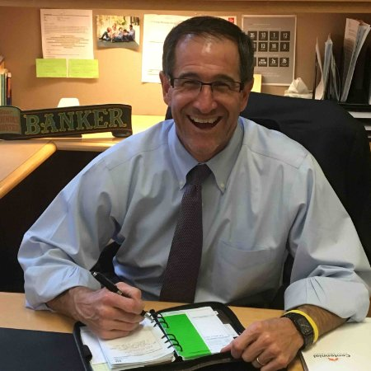](https://www.linkedin.com/in/christopherrwall/)](https://www.linkedin.com/in/christopherrwall/)**

**[Member Name](https://www.linkedin.com/in/christopherrwall/)**

**[Christopher Wall](https://www.linkedin.com/in/christopherrwall/)**[2nd degree connection2nd](https://www.linkedin.com/in/christopherrwall/)

**[Member Occupation](https://www.linkedin.com/in/christopherrwall/)**

[VP - Commercial Banker - Centennial Bank & Trust](https://www.linkedin.com/in/christopherrwall/)

* **[[](https://www.linkedin.com/in/craigbcarter/)](https://www.linkedin.com/in/craigbcarter/)**

**[Member Name](https://www.linkedin.com/in/craigbcarter/)**

**[Craig Carter](https://www.linkedin.com/in/craigbcarter/)**[2nd degree connection2nd](https://www.linkedin.com/in/craigbcarter/)

**[Member Occupation](https://www.linkedin.com/in/craigbcarter/)**

[Financial Consultant](https://www.linkedin.com/in/craigbcarter/)

* **[[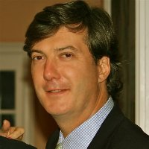](https://www.linkedin.com/in/wensley-mckenney-b9b815/)](https://www.linkedin.com/in/wensley-mckenney-b9b815/)**

**[Member Name](https://www.linkedin.com/in/wensley-mckenney-b9b815/)**

**[Wensley McKenney](https://www.linkedin.com/in/wensley-mckenney-b9b815/)**[2nd degree connection2nd](https://www.linkedin.com/in/wensley-mckenney-b9b815/)

**[Member Occupation](https://www.linkedin.com/in/wensley-mckenney-b9b815/)**

[CEO at Global Financial Credit, LLC / MedChex](https://www.linkedin.com/in/wensley-mckenney-b9b815/)

* **[[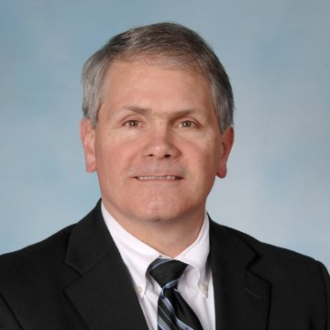](https://www.linkedin.com/in/davidhuller/)](https://www.linkedin.com/in/davidhuller/)**

**[Member Name](https://www.linkedin.com/in/davidhuller/)**

**[David L. Huller](https://www.linkedin.com/in/davidhuller/)**[2nd degree connection2nd](https://www.linkedin.com/in/davidhuller/)

**[Member Occupation](https://www.linkedin.com/in/davidhuller/)**

[President, ICAP Financial Services](https://www.linkedin.com/in/davidhuller/)

* **[[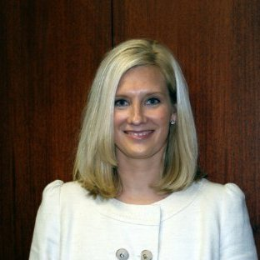](https://www.linkedin.com/in/gretchen-wile-b9a82b/)](https://www.linkedin.com/in/gretchen-wile-b9a82b/)**

**[Member Name](https://www.linkedin.com/in/gretchen-wile-b9a82b/)**

**[Gretchen Wile](https://www.linkedin.com/in/gretchen-wile-b9a82b/)**[2nd degree connection2nd](https://www.linkedin.com/in/gretchen-wile-b9a82b/)

**[Member Occupation](https://www.linkedin.com/in/gretchen-wile-b9a82b/)**

[Senior Vice President at CapitalSource Business Finance Group dba BFI Business Finance](https://www.linkedin.com/in/gretchen-wile-b9a82b/)

* **[[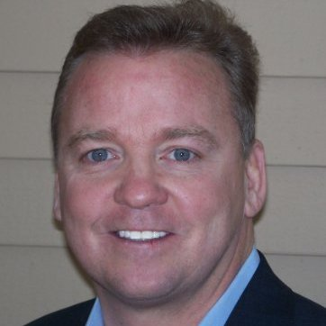](https://www.linkedin.com/in/chuckdoyle1/)](https://www.linkedin.com/in/chuckdoyle1/)**

**[Member Name](https://www.linkedin.com/in/chuckdoyle1/)**

**[Chuck Doyle, CTP](https://www.linkedin.com/in/chuckdoyle1/)**[2nd degree connection2nd](https://www.linkedin.com/in/chuckdoyle1/)

**[Member Occupation](https://www.linkedin.com/in/chuckdoyle1/)**

[Member, Board of Directors at Team IMPACT, Inc.](https://www.linkedin.com/in/chuckdoyle1/)

* **[[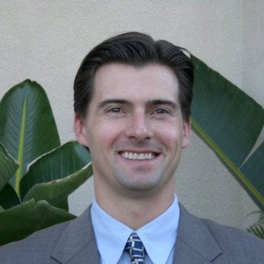](https://www.linkedin.com/in/jeyraud/)](https://www.linkedin.com/in/jeyraud/)**

**[Member Name](https://www.linkedin.com/in/jeyraud/)**

**[Jim Eyraud](https://www.linkedin.com/in/jeyraud/)**[2nd degree connection2nd](https://www.linkedin.com/in/jeyraud/)

**[Member Occupation](https://www.linkedin.com/in/jeyraud/)**

[Vice President of Wilshire Consumer Credit | Corporate Strategy | Business Development | Operations](https://www.linkedin.com/in/jeyraud/)

* **[[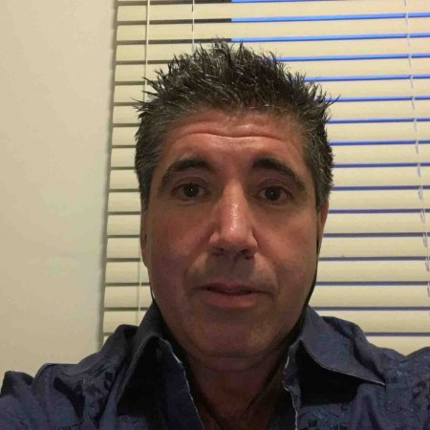](https://www.linkedin.com/in/richard-eitelberg-592877/)](https://www.linkedin.com/in/richard-eitelberg-592877/)**

**[Member Name](https://www.linkedin.com/in/richard-eitelberg-592877/)**

**[Richard Eitelberg](https://www.linkedin.com/in/richard-eitelberg-592877/)**[2nd degree connection2nd](https://www.linkedin.com/in/richard-eitelberg-592877/)

**[Member Occupation](https://www.linkedin.com/in/richard-eitelberg-592877/)**

[Contracted Sales Representative for PO Trade Capital, LLC](https://www.linkedin.com/in/richard-eitelberg-592877/)

**[Member Name](https://www.linkedin.com/in/irving-ayash-006914/)**

**[Irving Ayash](https://www.linkedin.com/in/irving-ayash-006914/)**[2nd degree connection2nd](https://www.linkedin.com/in/irving-ayash-006914/)

**[Member Occupation](https://www.linkedin.com/in/irving-ayash-006914/)**

[PRESIDENT of IDEAL CORPORATE FUNDING, INC.](https://www.linkedin.com/in/irving-ayash-006914/)

* **[[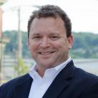](https://www.linkedin.com/in/evansegal/)](https://www.linkedin.com/in/evansegal/)**

**[Member Name](https://www.linkedin.com/in/evansegal/)**

**[Evan Segal](https://www.linkedin.com/in/evansegal/)**[2nd degree connection2nd](https://www.linkedin.com/in/evansegal/)

**[Member Occupation](https://www.linkedin.com/in/evansegal/)**

[President at Segal Financial, Commercial Mortgages and Business Loans](https://www.linkedin.com/in/evansegal/)

* **[[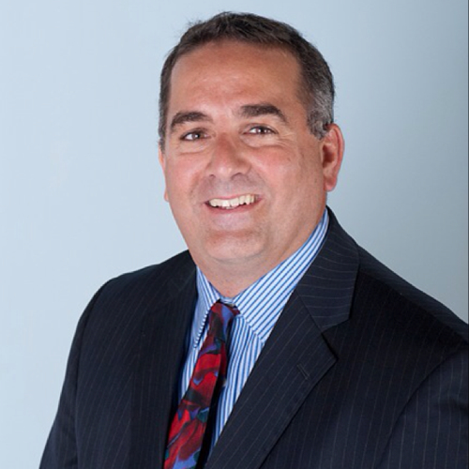](https://www.linkedin.com/in/forrester-faia-535939/)](https://www.linkedin.com/in/forrester-faia-535939/)**

**[Member Name](https://www.linkedin.com/in/forrester-faia-535939/)**

**[Forrester Faia](https://www.linkedin.com/in/forrester-faia-535939/)**[2nd degree connection2nd](https://www.linkedin.com/in/forrester-faia-535939/)

**[Member Occupation](https://www.linkedin.com/in/forrester-faia-535939/)**

[Director of National Sales and Business Development at Vendor Capital Finance](https://www.linkedin.com/in/forrester-faia-535939/)

* **[[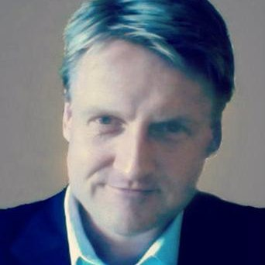](https://www.linkedin.com/in/richardhendersonjr/)](https://www.linkedin.com/in/richardhendersonjr/)**

**[Member Name](https://www.linkedin.com/in/richardhendersonjr/)**

**[Richard Henderson](https://www.linkedin.com/in/richardhendersonjr/)**[2nd degree connection2nd](https://www.linkedin.com/in/richardhendersonjr/)

**[Member Occupation](https://www.linkedin.com/in/richardhendersonjr/)**

[Vice President at Marlin Business Services Corp.® (NASDAQ: MRLN)](https://www.linkedin.com/in/richardhendersonjr/)

* **[[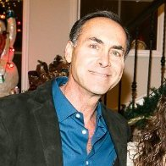](https://www.linkedin.com/in/howardnevins21/)](https://www.linkedin.com/in/howardnevins21/)**

**[Member Name](https://www.linkedin.com/in/howardnevins21/)**

**[Howard Nevins](https://www.linkedin.com/in/howardnevins21/)**[2nd degree connection2nd](https://www.linkedin.com/in/howardnevins21/)

**[Member Occupation](https://www.linkedin.com/in/howardnevins21/)**

[President, Marathon Financial Factoring Services - - Why wait for your invoices to pay?](https://www.linkedin.com/in/howardnevins21/)

* **[[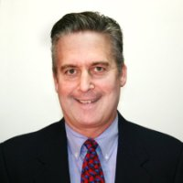](https://www.linkedin.com/in/william-elliott-264976/)](https://www.linkedin.com/in/william-elliott-264976/)**

**[Member Name](https://www.linkedin.com/in/william-elliott-264976/)**

**[William Elliott](https://www.linkedin.com/in/william-elliott-264976/)**[2nd degree connection2nd](https://www.linkedin.com/in/william-elliott-264976/)

**[Member Occupation](https://www.linkedin.com/in/william-elliott-264976/)**

[National Underwriting Manager at Triumph Commercial Finance](https://www.linkedin.com/in/william-elliott-264976/)

* **[[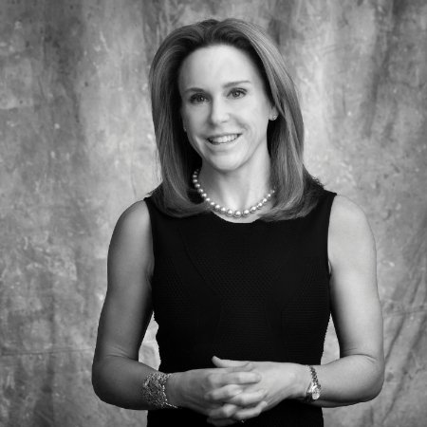](https://www.linkedin.com/in/robynbarrett/)](https://www.linkedin.com/in/robynbarrett/)**

**[Member Name](https://www.linkedin.com/in/robynbarrett/)**

**[Robyn Barrett](https://www.linkedin.com/in/robynbarrett/)**[2nd degree connection2nd](https://www.linkedin.com/in/robynbarrett/)

**[Member Occupation](https://www.linkedin.com/in/robynbarrett/)**

[Managing Member at FSW Funding and Owner, FSW Funding](https://www.linkedin.com/in/robynbarrett/)

* **[[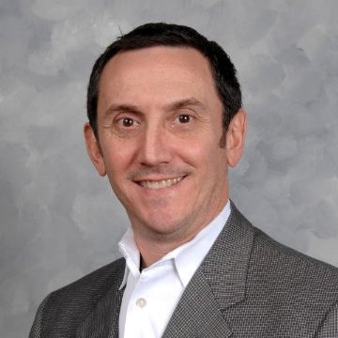](https://www.linkedin.com/in/markweisman1/)](https://www.linkedin.com/in/markweisman1/)**

**[Member Name](https://www.linkedin.com/in/markweisman1/)**

**[Mark Weisman](https://www.linkedin.com/in/markweisman1/)**[2nd degree connection2nd](https://www.linkedin.com/in/markweisman1/)

**[Member Occupation](https://www.linkedin.com/in/markweisman1/)**

[♦ Managing Director at Navidar ♦ Vistage Worldwide Chair ♦ Investment Banking ♦ M&A ♦ Exit Valuations](https://www.linkedin.com/in/markweisman1/)

* **[[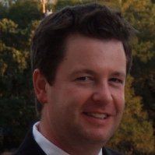](https://www.linkedin.com/in/steve-guth-a49981/)](https://www.linkedin.com/in/steve-guth-a49981/)**

**[Member Name](https://www.linkedin.com/in/steve-guth-a49981/)**

**[Steve Guth](https://www.linkedin.com/in/steve-guth-a49981/)**[2nd degree connection2nd](https://www.linkedin.com/in/steve-guth-a49981/)

**[Member Occupation](https://www.linkedin.com/in/steve-guth-a49981/)**

[Commerical Banker - Auto Dealer Services at JPMorgan Chase](https://www.linkedin.com/in/steve-guth-a49981/)

* **[[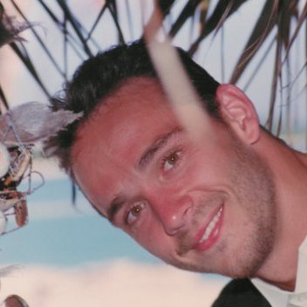](https://www.linkedin.com/in/jon-viberg-b90992/)](https://www.linkedin.com/in/jon-viberg-b90992/)**

**[Member Name](https://www.linkedin.com/in/jon-viberg-b90992/)**

**[Jon Viberg](https://www.linkedin.com/in/jon-viberg-b90992/)**[2nd degree connection2nd](https://www.linkedin.com/in/jon-viberg-b90992/)

**[Member Occupation](https://www.linkedin.com/in/jon-viberg-b90992/)**

[President & CEO at Commisceo Corporation](https://www.linkedin.com/in/jon-viberg-b90992/)

* **[[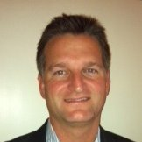](https://www.linkedin.com/in/bart-garbrecht-a339a1/)](https://www.linkedin.com/in/bart-garbrecht-a339a1/)**

**[Member Name](https://www.linkedin.com/in/bart-garbrecht-a339a1/)**

**[Bart Garbrecht](https://www.linkedin.com/in/bart-garbrecht-a339a1/)**[2nd degree connection2nd](https://www.linkedin.com/in/bart-garbrecht-a339a1/)

**[Member Occupation](https://www.linkedin.com/in/bart-garbrecht-a339a1/)**

[VP Sales/Marketing at Richert Funding, LLC](https://www.linkedin.com/in/bart-garbrecht-a339a1/)

**[Member Name](https://www.linkedin.com/in/steven-chaker-a35a01/)**

**[Steven Chaker](https://www.linkedin.com/in/steven-chaker-a35a01/)**[2nd degree connection2nd](https://www.linkedin.com/in/steven-chaker-a35a01/)

**[Member Occupation](https://www.linkedin.com/in/steven-chaker-a35a01/)**

[Senior Business Development Officer at ReadyCap Lending, LLC](https://www.linkedin.com/in/steven-chaker-a35a01/)

**[Member Name](https://www.linkedin.com/in/krramaswami/)**

**[Krishnan Ramaswami](https://www.linkedin.com/in/krramaswami/)**[2nd degree connection2nd](https://www.linkedin.com/in/krramaswami/)

**[Member Occupation](https://www.linkedin.com/in/krramaswami/)**

[Private Equity Investor](https://www.linkedin.com/in/krramaswami/)

**[Member Name](https://www.linkedin.com/in/valentinotrubiani/)**

**[Valentino Trubiani](https://www.linkedin.com/in/valentinotrubiani/)**[2nd degree connection2nd](https://www.linkedin.com/in/valentinotrubiani/)

**[Member Occupation](https://www.linkedin.com/in/valentinotrubiani/)**

[Retired at No Company](https://www.linkedin.com/in/valentinotrubiani/)

**[Member Name](https://www.linkedin.com/in/ifabertgoldberg/)**

**[Bert Goldberg](https://www.linkedin.com/in/ifabertgoldberg/)**[2nd degree connection2nd](https://www.linkedin.com/in/ifabertgoldberg/)

**[Member Occupation](https://www.linkedin.com/in/ifabertgoldberg/)**

[Executive Director at International Factoring Assoc.](https://www.linkedin.com/in/ifabertgoldberg/)

**[Member Name](https://www.linkedin.com/in/christina-carter-b36a78/)**

**[Christina Carter](https://www.linkedin.com/in/christina-carter-b36a78/)**[2nd degree connection2nd](https://www.linkedin.com/in/christina-carter-b36a78/)

**[Member Occupation](https://www.linkedin.com/in/christina-carter-b36a78/)**

[Professional Tax Preparer and Bookkeeper with over 25 years of experience.](https://www.linkedin.com/in/christina-carter-b36a78/)

Loading